STACKED BAR CHART - DISTRIBUTION OF ANSWERS FOR QUESTION 1
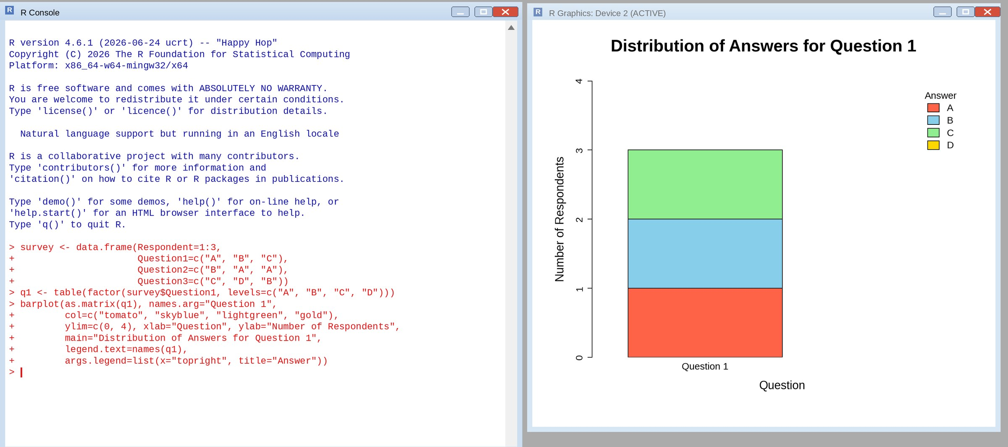
RADAR CHART - RESPONSE PATTERN ACROSS ALL QUESTIONS
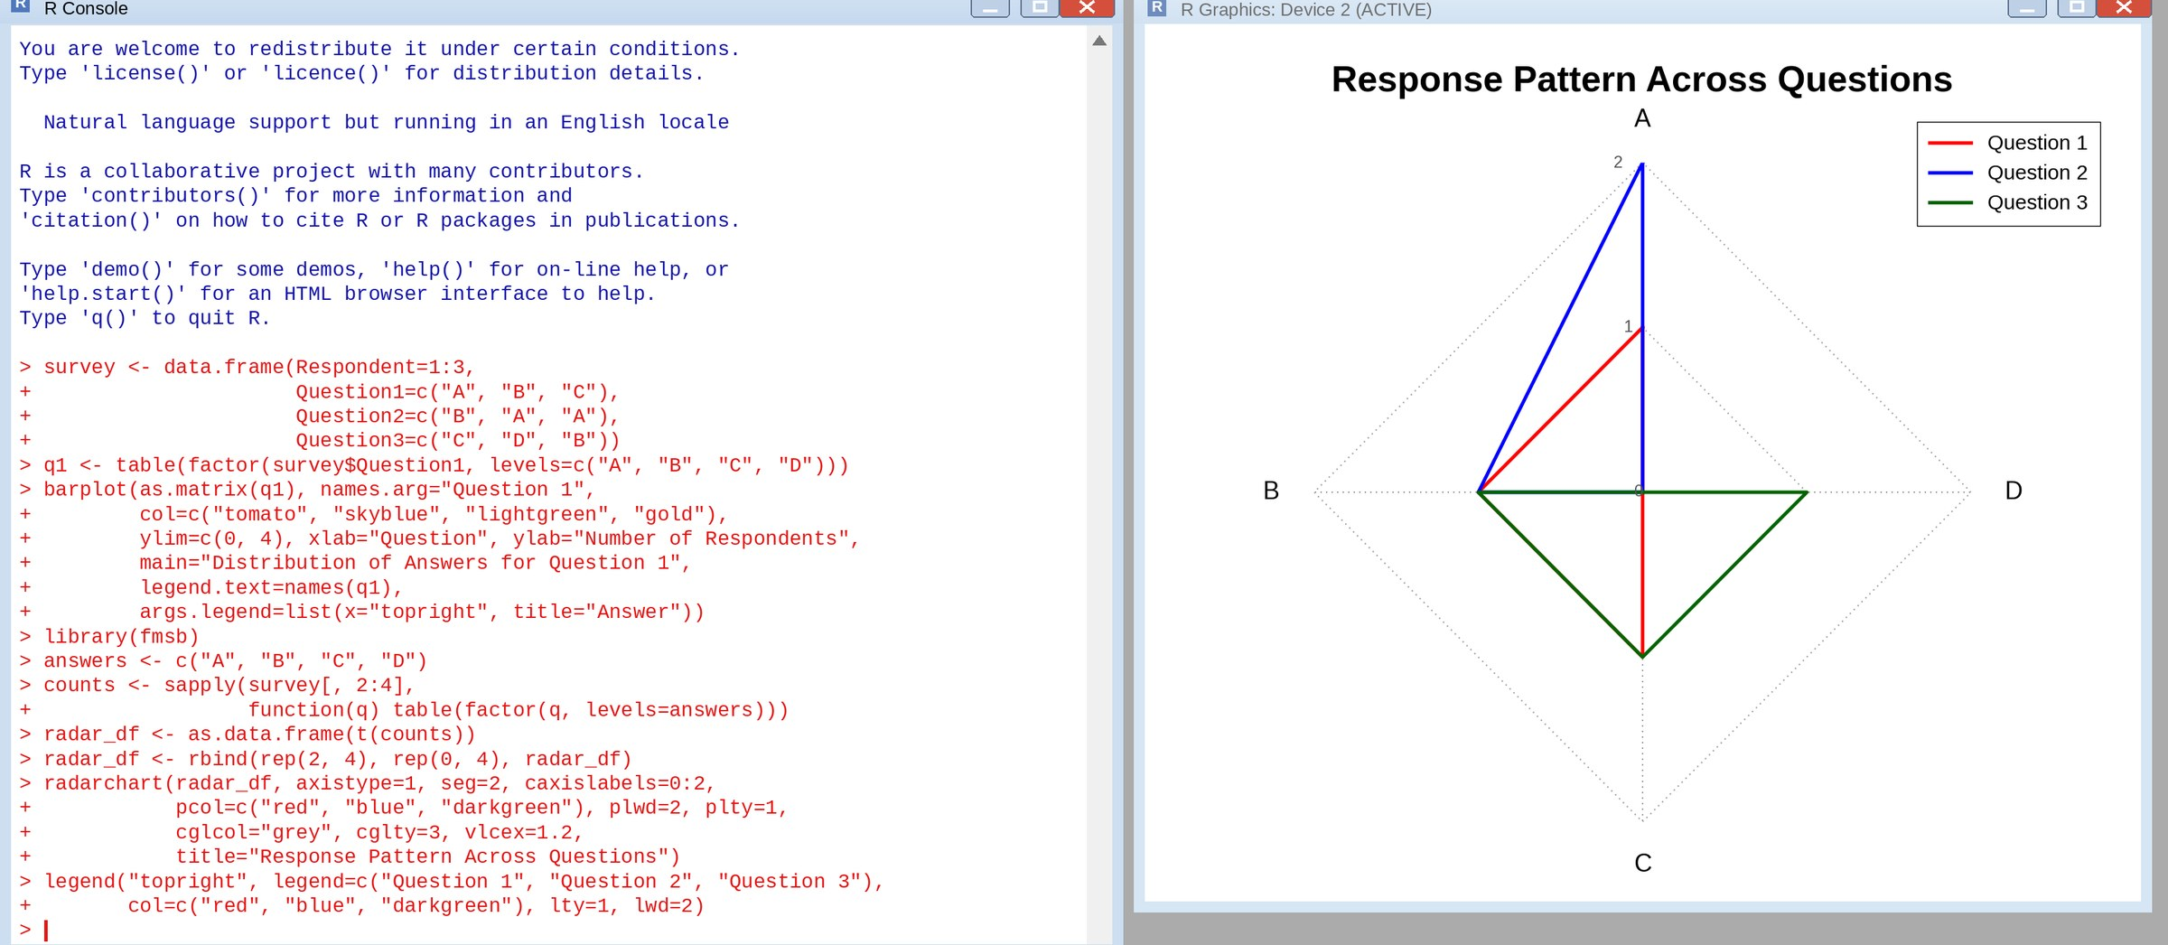
TABLE - SURVEY RESPONSE DATA
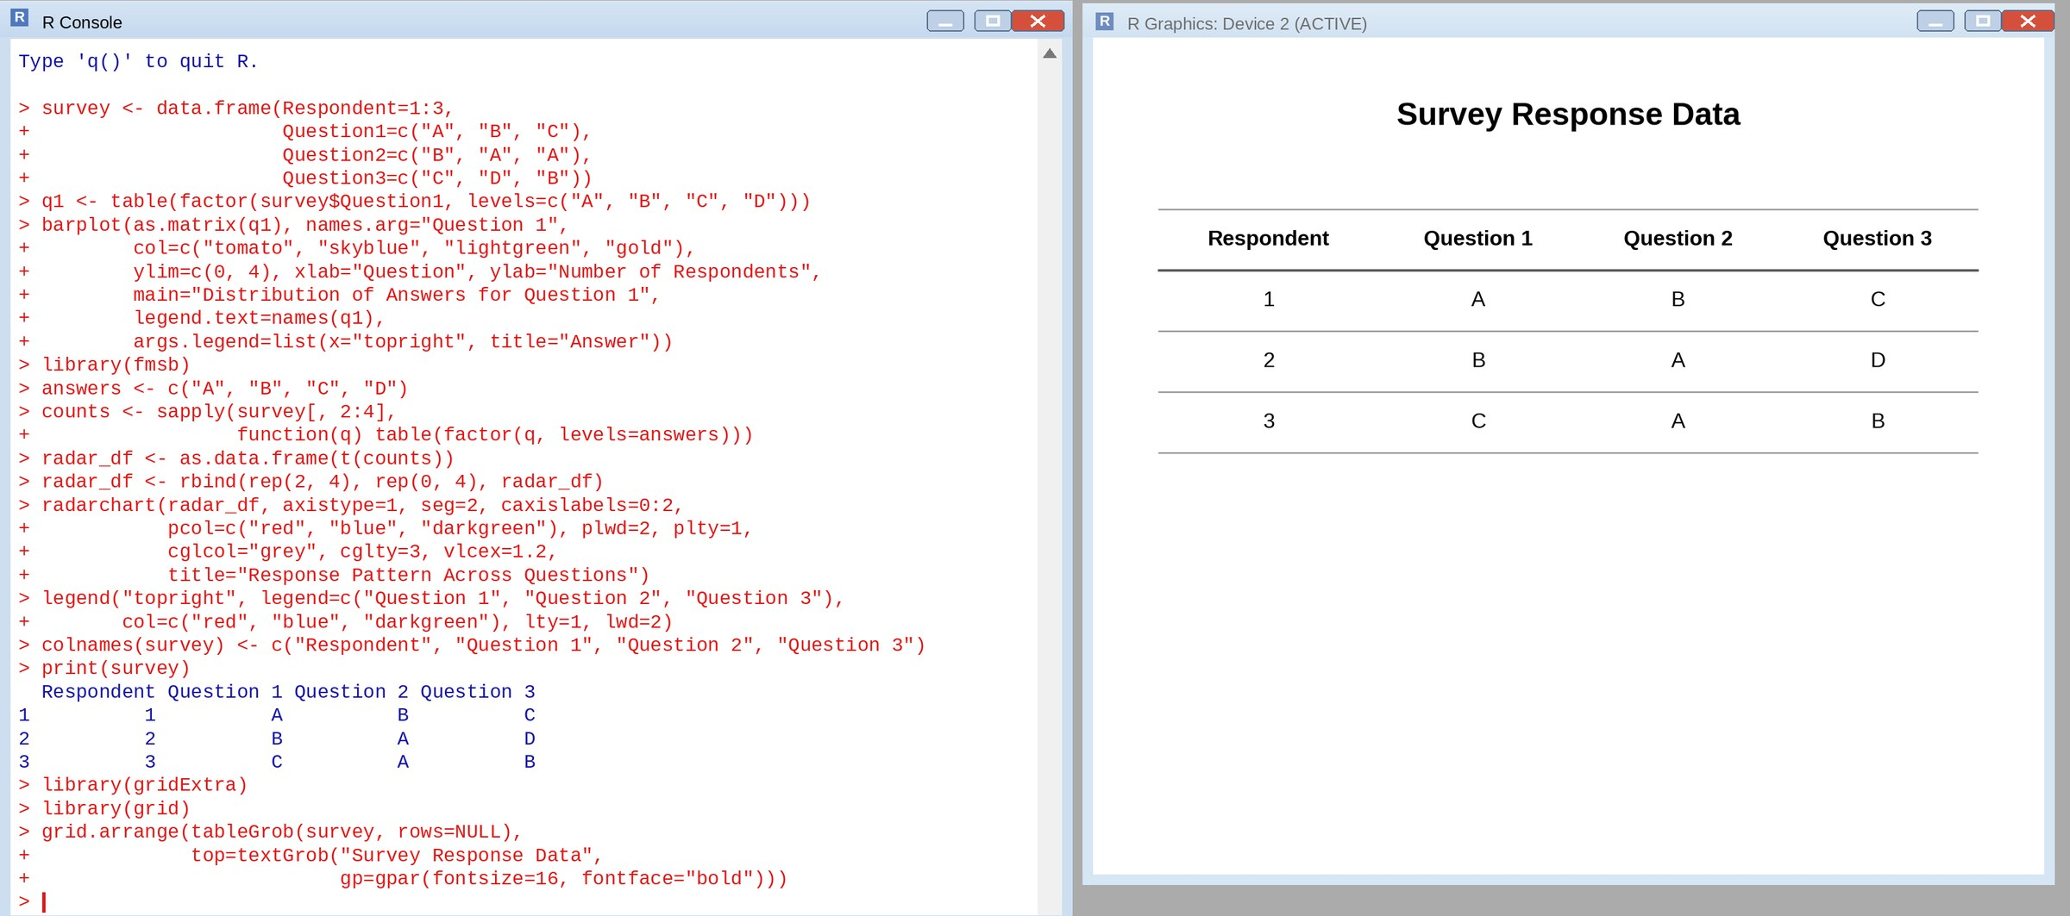
TABLEAU DASHBOARD - STACKED BAR CHART, RADAR CHART AND TABLE
